Pound shop play – © 2016 Mick Conway
I love pound (and “near-pound”) shops. You never know what you’ll find because the stock constantly changes and there are often amazing bargains on things like tools. I try not to throw little bits’n’pieces away. Yoghurt drink bottles, plastic bottle tops, bits of off-cut wood, take-away plastic food boxes with lids are all brilliant play resources.
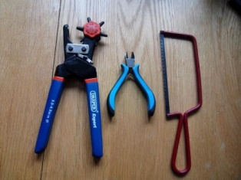
Most of these projects don’t need tools. But a rotating hole punch, a pair of snips and a junior hacksaw will make life a lot easier. It’s worth spending the extra on a good quality hole punch, but snips and hacksaws like these from the DIY/hardware sections of pound shops work perfectly well.
Pom-pom catapult - what you need: 6 standard lollipop sticks, 4 elastic bands, 1 small plastic bottle top and a bit of string. Pom-poms, or roll baking foil into balls to make equally light and non-lethal ammunition.
Secure four of the lollipop sticks with elastic bands at each end.
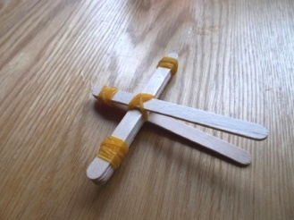
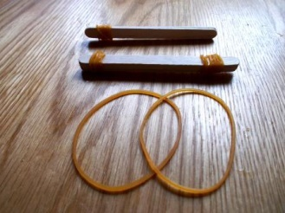
Secure one end of the remaining two sticks.
Put together as in the picture and secure with a band.

Make two holes in the bottle top and tie as shown to the launcher. A dab of PVA or general purpose glue will add extra security. Plasticine or blu-tack works just as well.
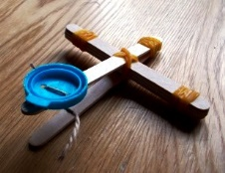
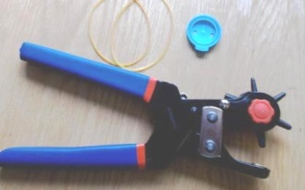
Load and fire!
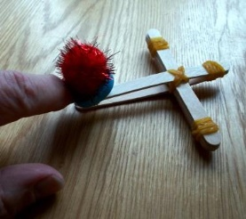
Experiment with different sizes of lollipop stick. What happens if you move the two sticks further forward or back on the cross-piece?
How could you make it with just four lollipop sticks? (Think two on their side with something to keep the middle section apart)

Paddle motor boat - what you need: 1 yoghurt drink pot (with lid on); 2 large lollipop sticks; 1 bit of a lollipop stick cut to about 3 cm long for the paddle; 1 thick and 2 thin elastic bands.
Secure the two lollipop sticks to the pot with the thick and one of the thin elastic bands – the thick band should be at the “front” – on the left in the pictures.
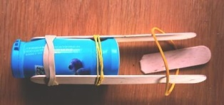
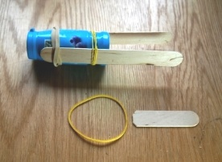

Put the remaining thin elastic band over the free ends of the lollipop sticks and insert the short piece of lollipop stick as shown on the right.
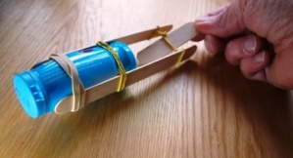
Wind clockwise for about 20 turns (more if the elastic band can take it) put in the water and let go!

What happens if you wind the paddle counter-clockwise? Or put the boat in the water “upside down”? What happens if you half fill the yoghurt pot with water?
Catamaran - what you need: 2 yoghurt drink pots with lids on; 2 large lolly sticks; 3 elastic bands; 2 bamboo skewers and a bit of paper. Make a skewer-sized hole in the centre of each lolly stick – easy peasy with the hole punch!
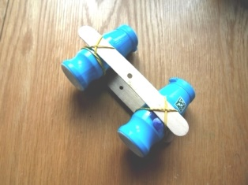
Attach the lolly sticks to the yoghurt bottles as on the left. Secure the skewers with an elastic band to make a cross shape.
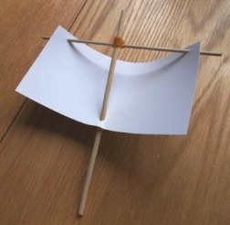

Punch two holes in the top edge of the paper and one in the bottom middle. Attach to the skewers as on the right – bottom hole first.
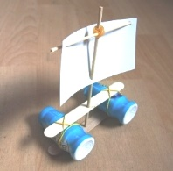
Float your boat and blow!
If the catamaran blows over, stabilise it by putting some water in the yoghurt pots
What happens if you turn the sail a bit slantwise?

Kazoo - what you need: 2 large lollipop sticks; 1 thick and two thin elastic bands; 2 pieces of plastic drinking straw about 2cm long.
Wrap the large elastic band end to end across one of the lollipop sticks. Make sure it lies flat with no twists.
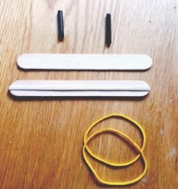
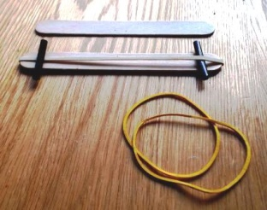
Put one of the straws under and one over the elastic band about 1cm in from each end.

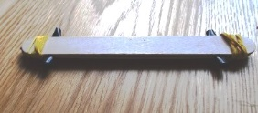
Put the second lollipop stick on top, and secure the ends as shown. (Start with the end with the straw on top of the thick elastic band to stop it falling out).

Blow through the lollipop sticks like a harmonica. Can you get different sounds by blowing hard or softly? Or blowing from the left or right ends? Sucking as well as blowing? Or from the other side?
Chinese Jenga - what you need: 8 chopsticks or 10- 15 large bamboo skewers; roll of sellotape or similar (keep the middles when the tape runs out when wrapping presents). If using bamboo skewers, cut the sharp ends off.
Set the chopsticks or skewers up as shown and play by taking turns to gently pull one stick out at a time, until somebody collapses it.
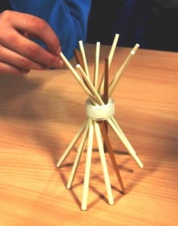
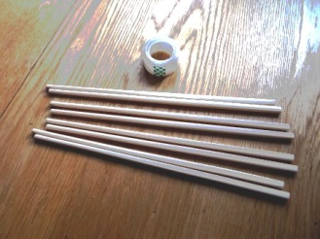
Setting it up can be just as much fun as playing it!

Try it with the chopstick thick ends up, then down. What happens on different surfaces - a shiny table top, on carpet or a sheet of paper? What else could you use? Drinking straws? Twigs?
Exploding boomerang - what you need: 4 large lollipop sticks – that’s it! Because it’s a bit fiddly, this works best if you do it in pairs helping each other. Or you could try using elastic bands to hold the lolly sticks in place at stages 1 and 2 while you do the tricky 3 and 4 stages!
Follow the sequence, making sure each stick sits over or under exactly as shown. I’ve used coloured sticks to make the instructions clear, but of course plain ones work just as well!
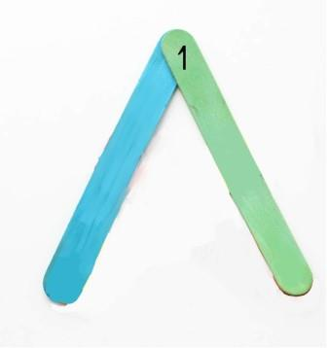
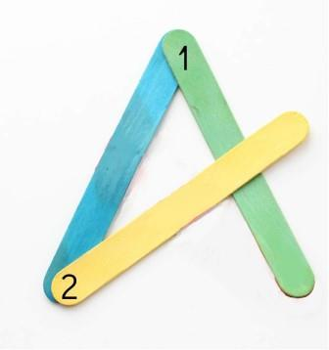

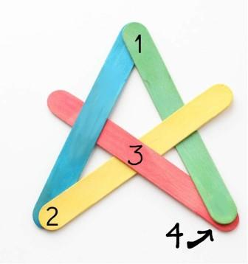
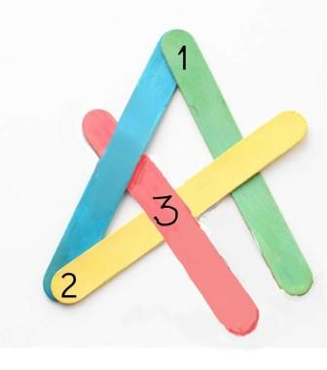
Elastic band block printing – what you need: elastic bands; bits of wood (child’s hand-sized); paper plates; kitchen or toilet roll or washing-up sponges; paint – acrylic or PVA based is best but any paint will work.
Throw it like a frisbee at the wall and watch it explode into its pieces. Then make it again and explode, and again and explode, and again and…
Could you add two more sticks to make it fly further? (Think a stick under 1, over 3 and then under another stick which is under 2 and 4 in the picture)

Wrap elastic bands randomly around the bits of wood. Experiment with different thicknesses and sizes of elastic bands but don’t put too many on at once – about three to five seems to work best.
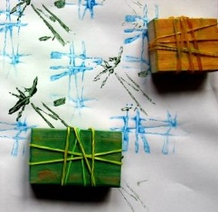
Wet a couple of sheets of kitchen roll/toilet paper, fold to fit on the paper plate and squeeze some paint on.
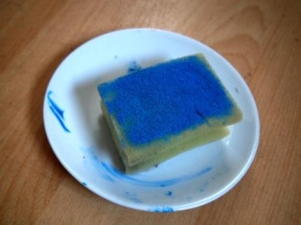
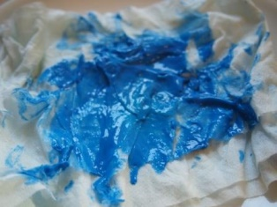
Or squeeze paint directly onto a damp washing up sponge. Press the printing blocks onto the paint and start making your patterns.
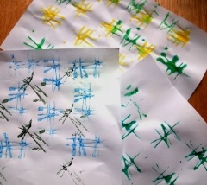
Remember there are six sides to each printing block – try them all to see what shapes they make. Use different blocks and colours on the same page.
Swap your blocks with other people – their block shapes might be exactly what you need to make your perfect pattern.
Experiment with thick cotton or jute string instead of (or with) elastic bands. Try wrapping them around things like bits of broom handle that you can roll to make non-stop patterns.
Website links to more resources

Cheap bulk lollipop sticks – 1,000 for £5.98 inc VAT on Amazon or slightly more expensive but better quality at £8.39 inc VAT here
http://www.tts-group.co.uk/shops/tts/Products/PD1719221/
Catapult launcher
http://kidsactivitiesblog.com/28871/catapult-for-kids-to-make
Kazoos
http://sophie-world.com/crafts/popsicle-stick-kazooo
http://www.housingaforest.com/popsicle-stick-harmonica/
Exploding boomerang
https://uk.pinterest.com/pin/70228075416501935/
Rubber band stamp blocks
http://www.metro-parent.com/scrap-craft-how-to-make-wood-block-and-rubber-band-stamps/
Boats
http://www.instructables.com/id/Rubber-Band-Powered-Altoids-Boat/?ALLSTEPS
https://www.youtube.com/watch?v=NMxUuuqBi3E
Bracelets
http://suzyssitcom.com/2011/04/feature-friday-popsicle-bracelets.html
My Playfile website “Links We Like” to an online treasure trove of play ideas
http://playfile.co.uk/links/
Play England Exploring Nature Play recipe cards
http://www.playengland.org.uk/resources/nature-play-activity-recipes.aspx
Instructables – how to make loads of things – a very mixed bag but some fun stuff. This ‘craft’ page is actually better than the ‘play’ page
http://www.instructables.com/tag/type-id/category-craft/

Many thanks to the folks who came to my Pound Shop Play workshops at the Re:Play Spirit of Play 2016 conference and tried and tested most of this in practice. You were great fun and got right into the spirit of play – I hope other folks enjoy trying these projects too!
Mick Conway

